Homework 5

3.1

a)

2.5 % 97.5 %

(Intercept) -1.906960983 3.245634379

lcavol 0.412298699 0.761744954

lweight 0.116603435 0.792331414

age -0.041840618 0.002566267

lbph -0.009101499 0.223209561

svi 0.280644232 1.251670420

lcp -0.286344443 0.075395916

gleason -0.267786053 0.358069248

pgg45 -0.004260932 0.013311395

5 % 95 %

(Intercept) -1.485718237 2.824391633

lcavol 0.440867156 0.733176497

lweight 0.171846568 0.737088281

age -0.038210200 -0.001064151

lbph 0.009890745 0.204217317

svi 0.360029029 1.172285623

lcp -0.256770899 0.045822373

gleason -0.216620186 0.306903382

pgg45 -0.002824333 0.011874796

b)

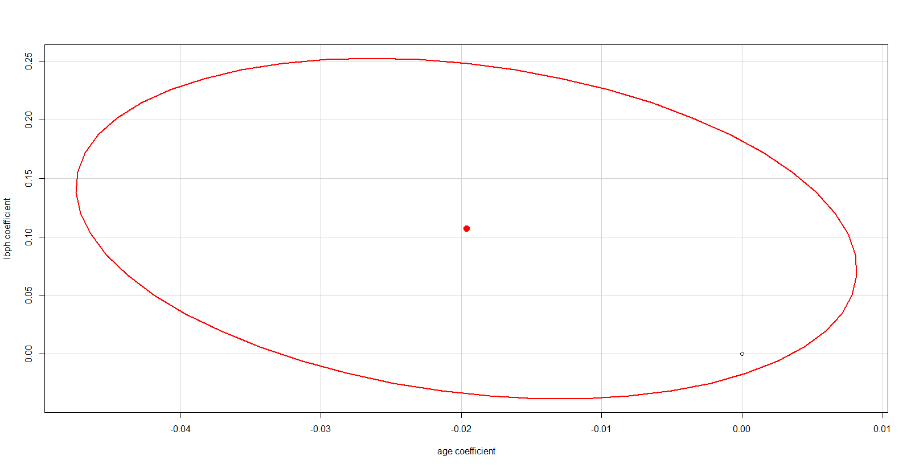

$$H_{0}:B_{lbph}=B_{age}=0 |B_{age},B_{lcp},B_{gleason},B_{pgg45}, B_{lcavol}, B_{lweight}, B_{svi}≠0$$

$$H_{A}:B_{lbph} or B_{age}≠0|B_{age},B_{lcp},B_{gleason},B_{pgg45}, B_{lcavol}, B_{lweight}, B_{svi}≠0$$

In this case, we would fail to reject the null, because the point (0, 0) is in our confidence region. Thus, $B_{age}$ or $B_{lbph}$ could plausibly be 0.

c)

$$H_{0}:B_{age}=0 |B_{age},B_{lbph},B_{lcp},B_{gleason},B_{pgg45}, B_{lcavol}, B_{lweight}, B_{svi}≠0$$

$${H_{A}:B}_{age}≠0 |B_{age},B_{lbph},B_{lcp},B_{gleason},B_{pgg45}, B_{lcavol}, B_{lweight}, B_{svi}≠0$$

After running the permutation test, I received a p-value of .096. I therefore have weak evidence to reject the null hypothesis, and I have weak evidence to conclude that the coefficient for age is 0.

d)

$$H_{0}:B_{age}=B_{lbph}=B_{lcp}=B_{gleason}=B_{pgg45}=0 | B_{lcavol}, B_{lweight}, B_{svi}≠0$$

$$H_{A}:OfB_{age},{ B}_{lbph},{ B}_{lcp},B_{gleason}, B_{pgg45} at least one isn^{'}t 0 | B_{lcavol}, B_{lweight}, B_{svi}≠0$$

After conducting an F-test between a model using all predictors, and a model using just lcavol, lweight, and svi, I received a p-value of .2167. I therefore conclude that I fail to reject the null hypothesis, and should conclude that the coefficients for age, lbph, lcp, gleason, and pgg45 could be 0, given that lcavol, weight, and svi have coefficients not equal to zero (they are in the model).

5.

To find a formula that relates $R^{2}$ and our F-statistic, first note:

$$F=\frac{\left(TSS-RSS\right)/(p-1)}{RSS/(n-p)}$$

And that

$$R^{2}=1-\frac{RSS}{TSS}=\frac{TSS-RSS}{TSS}$$

Manipulating algebraically we can show that:

$$R^{2}=1-{\left(1+F×\frac{p-1}{n-p}\right)}^{-1}$$

6.

a)

Coefficients:

Estimate Std. Error t value Pr(>|t|)

(Intercept) -0.072081 0.852543 -0.085 0.9331

money 0.009578 0.005213 1.837 0.0749 .

sex -0.149008 0.418525 -0.356 0.7240

love 1.919279 0.295451 6.496 1.97e-07 \*\*\*

work 0.476079 0.199389 2.388 0.0227 \*

Based on the summary() output, the love predictor is the only one significant at the 1% level.

b)

2 3 4 5 6 7 8 9 10

1 1 4 5 2 8 14 3 1

Based on the table() output, it is obvious that the response variables are not continuous, and therefore can’t be normal, so the errors won’t be either.

c)

$$H_{0}:B_{money}= 0 | B_{love}, B_{sex}, B_{work}≠0$$

$$H_{0}:B_{money}≠0 | B_{love}, B_{sex}, B_{work}≠0$$

After completing the permutation test, I received a p-value of .088. I therefore have weak evidence to reject the null, and have weak evidence to conclude that the coefficient for money is not equal to 0, given that the coefficient for love, sex, and work are not equal to zero (they are in the model).

d)

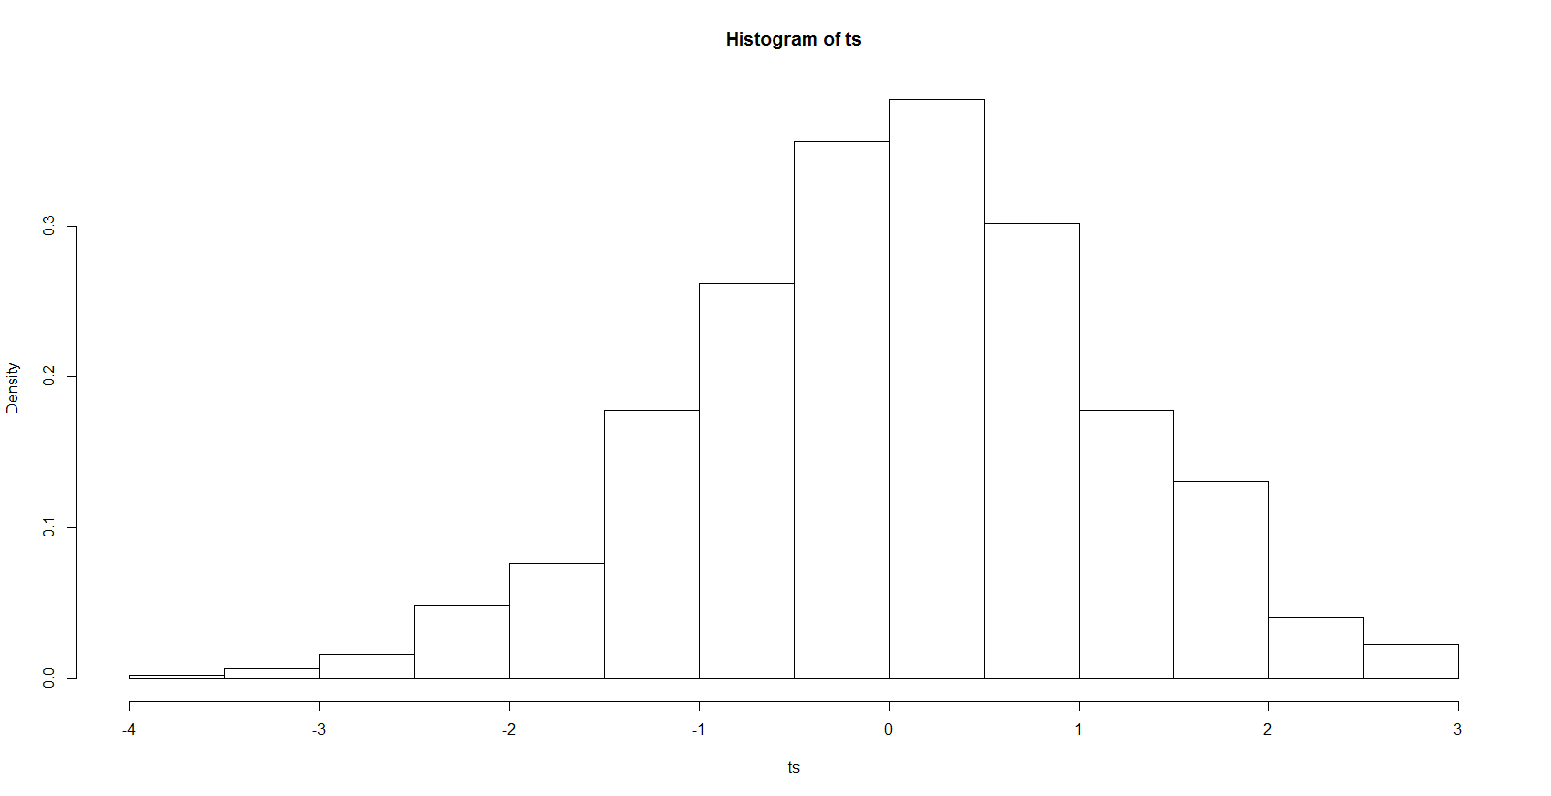

e)

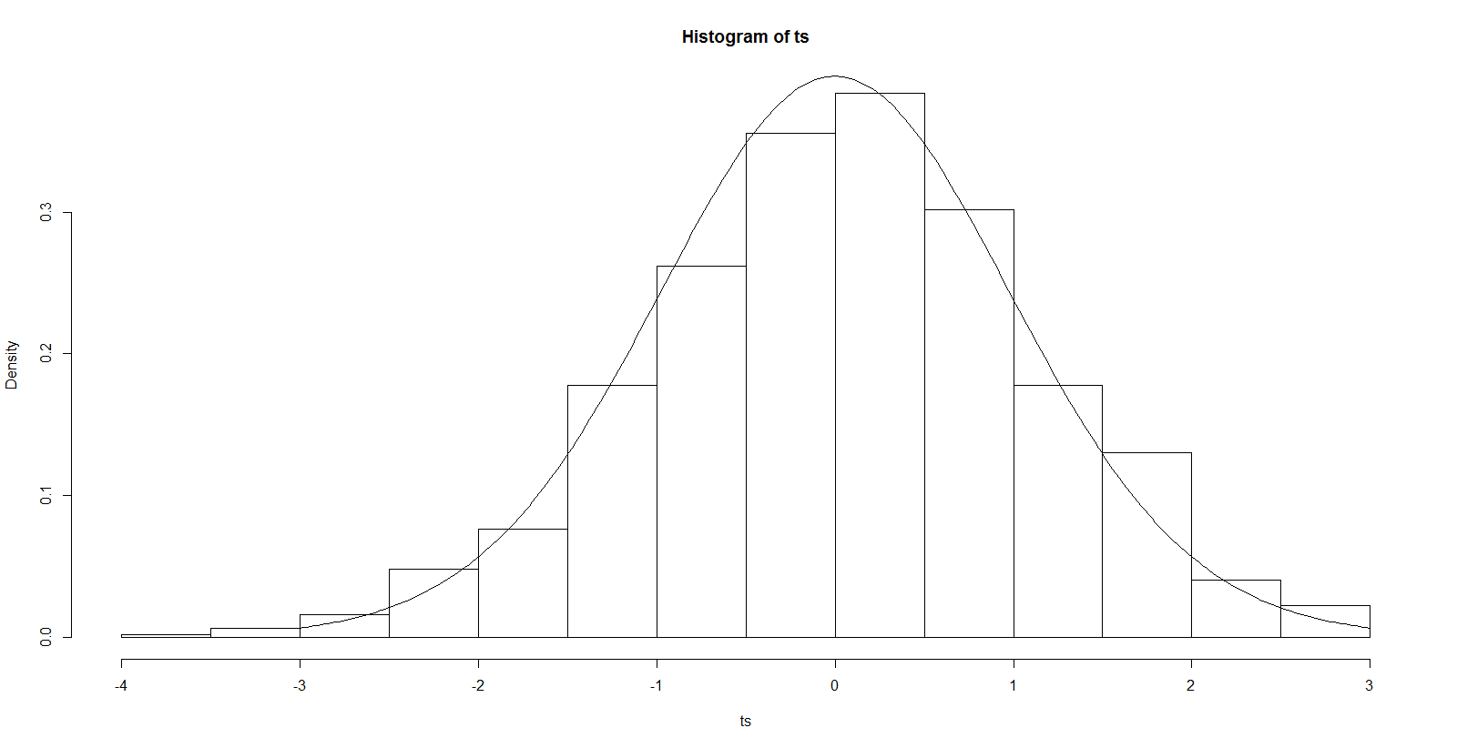

f)

95% Confidence Intervals

money

2.5% -0.0001938582

97.5% 0.0188029029

90% Confidence intervals

Yes, 0 does fall within this bound, which makes sense since in our permutation test I showed there was weak evidence to conclude that the coefficient for money wasn’t 0. Based on this interval, 0 is a plausible value. In line with my hypothesis test.

money

5% 0.001504252

95% 0.017763374

This time 0 doesn’t fall into the confidence interval. However, this should make sense, because our hypothesis test from about was based on the an alpha of .05, not an alpha of .1, which is what the corresponding 90% confidence interval is associated with.